Digital Newsletter
October, 2020
Photo by Mark Duffel

Happy October

By Sthefany Rosales/ALMA Intern
Hello, fellow ALMA members and happy October! It’s been a while since we’ve sent you some updates, but that does not mean there isn’t amazing work being produced. Here at ALMA, we love to see your continuing hard work and commitment to outstanding journalism. With that being said, in this newsletter you’ll read about award winners, new elected leaders and how a freelance correspondent in Mexico City has been working during the Pandemic

THIS MONTH’S
TOP STORIES

Félix wins more recognition
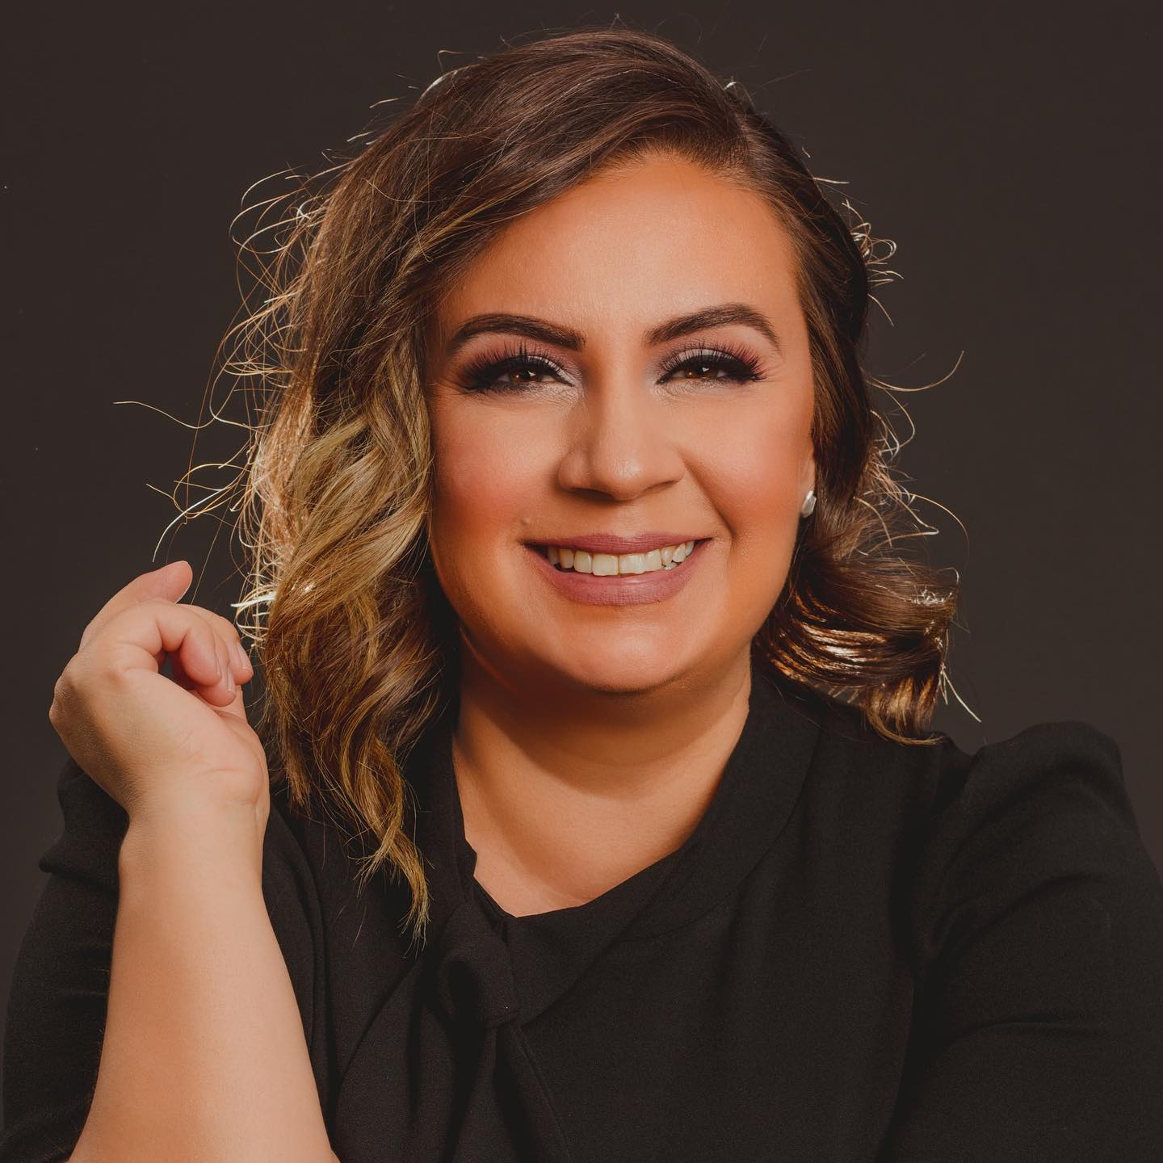
Congrats, Maritza L. Félix, for all your recent recognitions!

ALMA member Martiza L. Félix was recognized as the winner for the community column writing category presented by the Arizona Press Club. Not only was she announced the contest winner for the 2019 Journalism Award presented by the Arizona Press Club, but she made history. Her work, which was originally published by Prensa Arizona, is the first Spanish-language publication to win the Community Writing Award from the club.

Some of her featured work included, Los muertos que me volvieron a México and La hispanidad: El nuevo rostro de los Estados Unidos.

Félix also wrote one of 10 projects selected for the Education Writers Association’s 10th Class of EWA Reporting Fellows. EWA supports fellow journalists to produce stories related to informing the community about “consequential issues in education.”

Her in-depth project was a detailed look into how Latino students with disabilities face additional challenges with distance learning as a result of language barriers and a lack of resources during the COVID-19 pandemic. Felix revealed how these students’ parents adapted to take on more active roles in ensuring their children don’t fall behind.

She also contributed to the launch of an English-language podcast, A Better Life. The podcast was created by immigrants or children of immigrants who speak about how the pandemic has changed their lives and challenged their ideas about the promise of America.

And to top things off, Félix is an 50 Women Can Change the World Journalism graduate, a leadership gender parity program created by the non-profit organization Take the Lead working for leadership gender parity by 2025.

Upcoming deadline for journalism scholarship
Have you heard of the Valley of the Sun SPJ $500 Scholarship? Created by the Society of Professional Journalists Valley of the Sun Chapter, this scholarship is offered to ALL students across Arizona studying journalism, mass communications or a related field.

All applicants must submit an essay, between 300 and 500 words, exploring the following topic:

“In 2020 we’ve seen numerous instances of working journalists who find themselves in danger both at home and abroad. What can journalists and news organizations do to keep journalists safe in these turbulent times? Where possible, what should institutions such as cities and their police agencies do to lessen the danger to reporters?”

Share this with your students. The deadline for submission is Nov. 6, 2020. You can read the full details related to the essay and requirements here.

Reporting from Mexico City

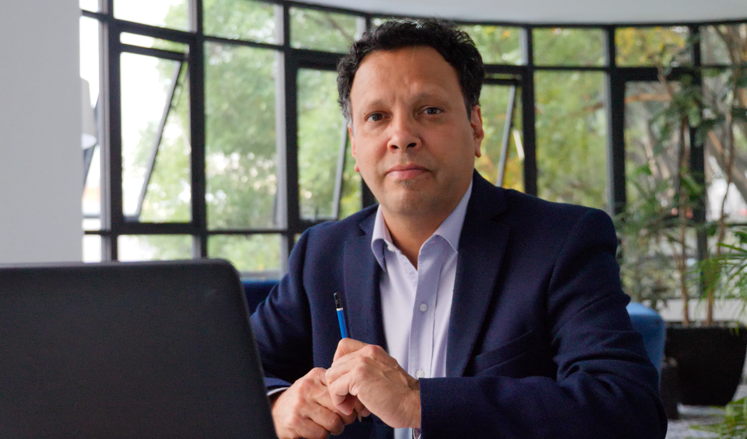
“I think it’s really crucial that you always keep somewhere in your imagination a place for your dreams and you never forget them. You always spend a little bit of time each day daydreaming and imagining yourself doing your dream job.”
-Franc G. Contreras

Being an independent journalist has its pluses and minuses, but freelancing during a global pandemic can add a ton of pressure to an already tough job. We had an opportunity to ask indie broadcast journalist Franc Contreras.

Contreras is based in Mexico City and works as a Mexico Correspondent for China Global Television Network (CGTN). His main responsibility as a correspondent is covering top news stories for television viewers across the globe who tune into the network. Since 1996 he has worked as a freelance broadcast correspondent covering Mexico and Central America.

Contreras, 57, covers stories related to politics, borderlands and immigration reform. He now is working on covering how the immigration issue occurring in Arizona will play into the 2020 election and its aftermath. Some of his most recent work also covers how CDMX street vendors are trying to survive the pandemic.

“A lot of my work is about translating the story of Mexico, with all of its amazing complexities, to foreign audiences that speak English,” said Contreras. Read entire interview.

New NAHJ Board Members

The 2020 NAHJ national board elections results are in! The National Association for Hispanic Journalists welcomed eight new Board of Directors to the team, along with an existing board member who was elected to a new role.
Please join us in congratulating the 2020 winners:
- Nora Lopez, President
- Julio-César Chávez, VP of Broadcast
- Yvette Cabrera, VP of Digital
- Arelis R. Hernández, VP of Print
- Keldy Ortiz, Financial Officer
- Blanca Rios, Secretary
- Jennifer Marcial Ocasio, Spanish At-Large Officer
- Jessica Retis, Academic At-Large Officer
- McNelly Torres, General At-Large Officer
- Luis Joel Méndez González, Student Representative

New president at SPJ

In another national development, Rebecca Aguilar, a freelance reporter in Texas, was elected to serve as president for the Society of Professional Journalists. This makes her the first Latina and woman of color to lead SPJ. Aguilar has been serving in the community as a reporter for 36 years, covering issues related to politics, social justice and entertainment.

She has 50 awards and nominations, including several Emmys.

Some of her investigative work has helped reveal corruptions by school board members, uncovered medical abuse of veterans and closed down foster care placement due to abuse.

“Two other Latinx journalists and I are now half the six elected officials, another first in the organization's history. We hope to show journalists of color that SPJ is for all journalists, and together we can help the news business survive and thrive during these challenging times,” said Aguilar.

Aguilar also says she would like to recognize SPJ members who are “helping break this barrier because their votes sent the message that Latinas are equal and capable of leading an organization that is more than 100 years old.”

Open Phoenix Coyotes sports intern position
The Phoenix Coyotes sports organization is seeking an individual to serve as the Spanish-language sports intern. This is a paid position working 15-20 hours per week.
Some of the job responsibilities include working with the marketing team to handle the Spanish language Coyotes social media accounts. You can find more on the responsibilities and qualifications for the position at the Arizona Coyotes Job Board.

Sierra recovering from COVID-19
Finally, we are relieved to know that former ALMA board member Lorenzo Sierra, is recovering from a severe bout with COVID-19 coronavirus.

You can read Sierra’s harrowing first-person account here.

Newsletter items, comments or suggestions can be sent to azlatinomedia@gmail.com. ALMA Newsletter is produced by ASU Cronkite student Sthefany Rosales.

READ MORE ON OUR WEBSITE
Disclaimer: This newsletter is for informational purposes only; it does not constitute legal advice and should not be construed as such. In addition, any views, thoughts or opinions expressed in the text belong solely to the person being quoted and doesn’t necessarily reflect the views of the newsletter, editor or reporter of our organization.
ALMA Digital #follow us

